eToys Book

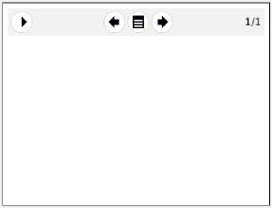
The Book is one of the most useful objects in eToys. You can use it to do Slideshows, class diaries and albums; register observations and even create your own animated book. The most interesting is that you can insert any kind of element (object) inside a book. For example, you can add text, drawings and even animations in order to bring your book to live. So let’s see some tips before you create your first book!
First of all, we need to start eToys. Look this icon in your computer:
 | 4. Buttons to navigate to the previous and next pages  3. Opens the book menu with extra options
1. Once eToys is open, you can find the Book in the Supplies box
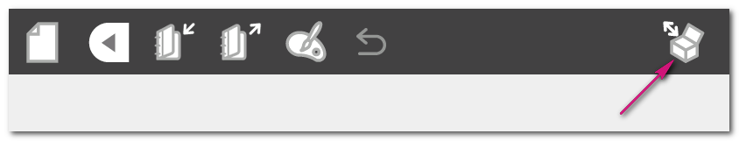
2. When the Supplies box opens, you are going to will see the Book icon,
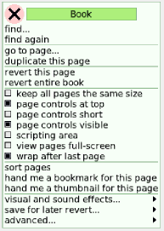
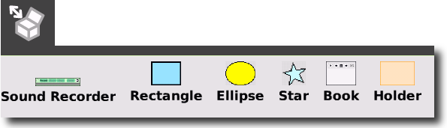
3. Now, just drag the Book icon over the World to create a new book,
2. Shows the controls (next page, last page, etc) in the menu.

1. Duplicates the current page. Useful when you draw a background

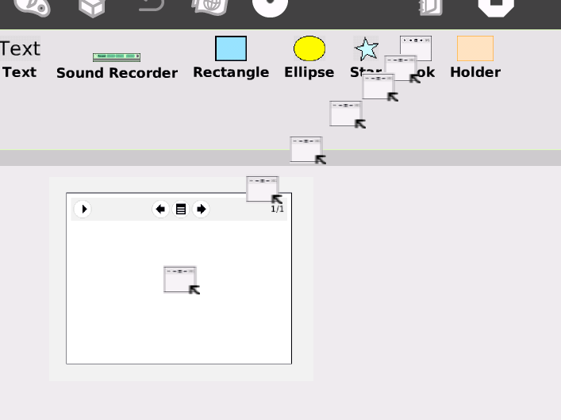A new book is now ready to be created!
4. Go to the 1st page after the last one.

3. Shows the book in full screen. Useful when you are doing a slides show.

Options of the Book
The book is really simple to use. You just need to drag your drawings, texts and pictures inside it. But there are a few controls that might be useful when you are working with it.
1. Shows more controls for the book

2. Shows the current page and the total number of pages

If you click over the More controls button (1), the book menu will show a few more options to navigate through the pages, the most important being the one to add pages. However, the more advanced features can be found in the Options menu, the central button on the bar.
Here are some of the most important options:

6. A few advanced options. The most useful is “set background color for all pages”.

5. Add sound effects for a page.

Some Useful Techniques

Painting a background
The Book is often used to create stories with animated characters. But in order to do animations in eToys, it is necessary to draw the scenario (background) separated from the characters (objects).
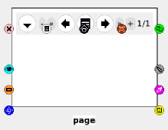
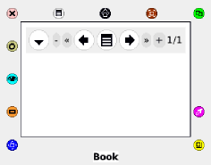
1. Click with the circle button one time over the book, and you will see the halo, with the word “book” under it. Now click again over the book, and you will see that the word changes to page.

If you look closer to the image, you might also notice another details. The pen icon , should have showed up. Well, it is exactly in this icon that we should click in order to paint our scenario.
Changes the size of the text

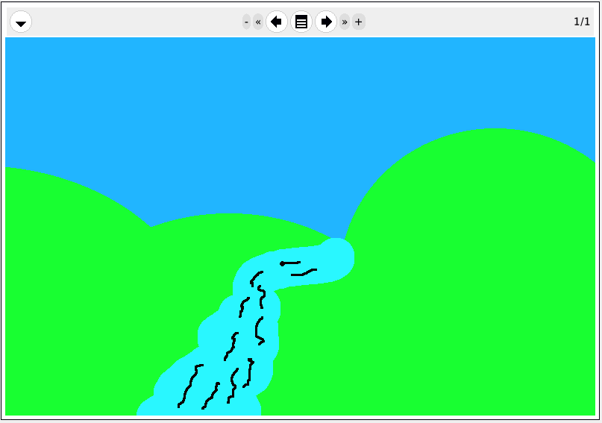
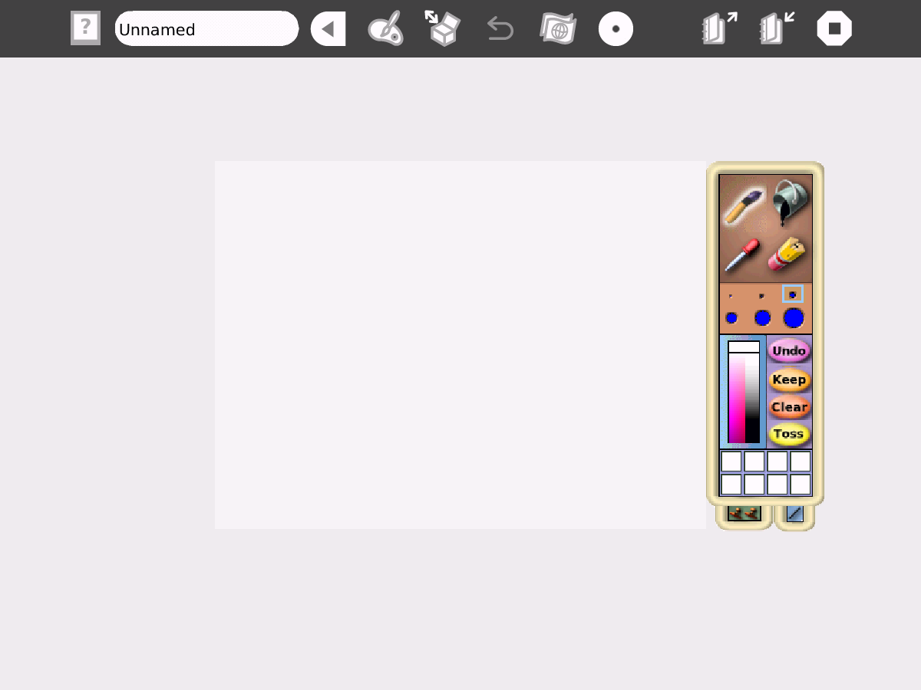
When your drawing is ready, click on keep
Choose Colors
Drawing area

Fill of color
Eraser
Use it to draw
Pick a color
Choose the pen size

Adding Text to the Book
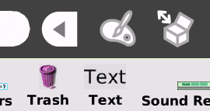
It is also very easy to add some text to the book. What we need to do is to open again our supplies box and look for the text object.

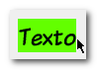
Again, just drag the Text over the book, and drop it. To start writing, just select the text and start typing.

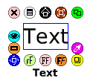
Now, you might have noticed that the size of the text isn’t ok, or you want to change the font or the size of your text. So, what we need to do is to call the halo, by clicking the Text with the circle button.
Rotate the text. You can do cool effects with this one.

Changes the text’s emphasis (bold, italic) and alignment (center, left)

Changes text’s style

Adding drawings to the Book
There are two ways of adding a drawing to the book. If you already have a drawing outside the book, just drag it and drop over the book. The drawing will be automatically added to the current page. The second way is to create a new drawing, by clicking the Paint icon  on the top menu.
In our case, we created a first page to our story.
My drawing after click on keep

