
LESSON PLAN
NUMBERS with dice
Gcompris


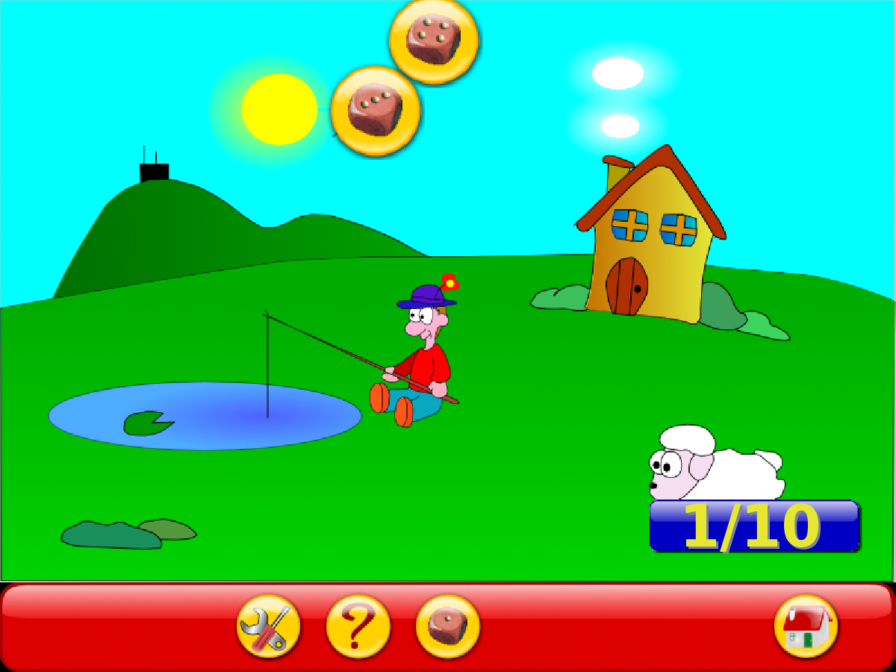


How to play: With the keyboard, type the number of dots you see on the falling dice.

GOALS:
- To develop counting skills
- To get familiar with numbers (visual representation, sound in English)
- To get familiar with laptop keyboard
Click to enable the sound
CLICK:

