
LESSON PLAN
ALPHABET - letter and sound
Gcompris

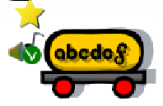

CLICK:

CONTEXTUALIZATION: Say loud or sing a song for the English alphabet. Show (or write) a letter and ask the name in English.

HOW TO PLAY: Listen the letter spoken and click with mouse in that letter. You can listen again clicking on the mouth icon.

GOALS:
- To get familiar with English alphabet (letter-name recognition, visual representation - minuscule/majuscule, sound)

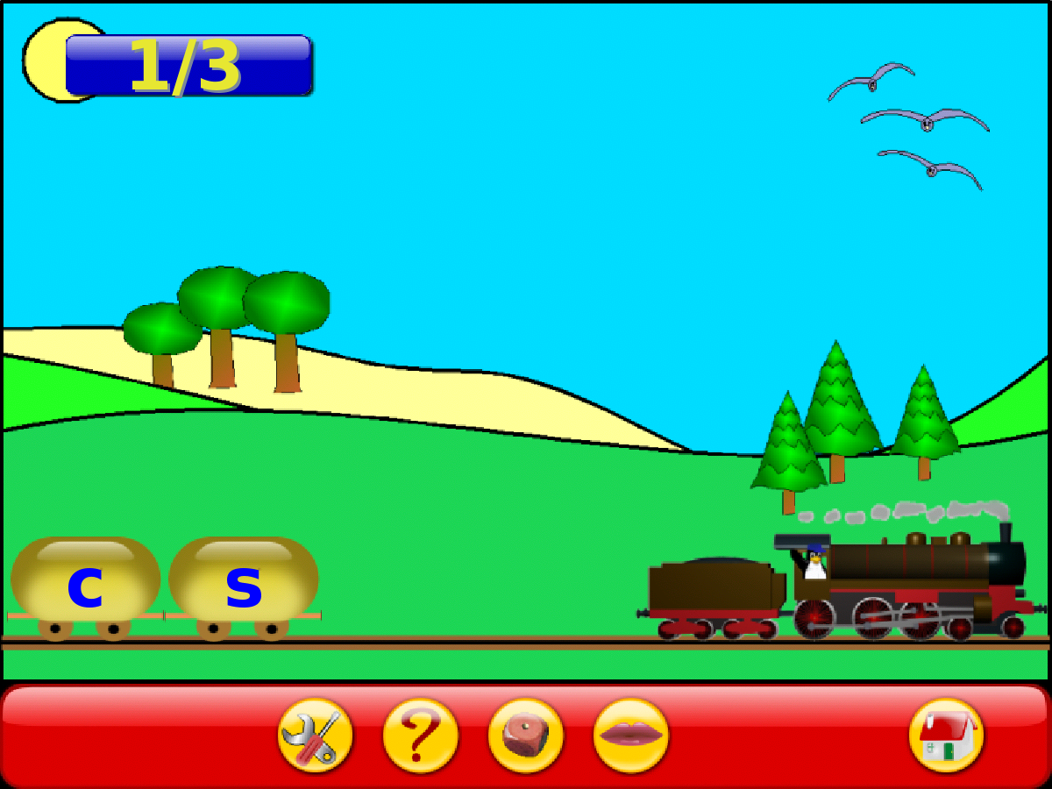
Click to enable the UPPERCASE
