
LESSON PLAN
ALPHABET
Gcompris

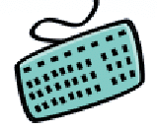
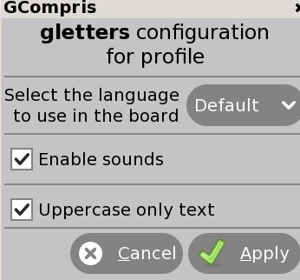
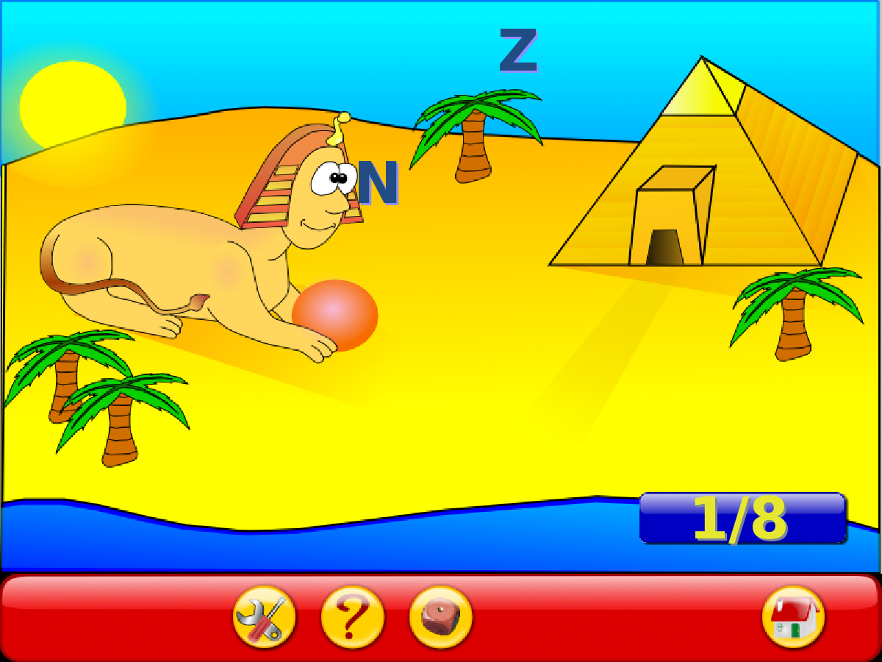

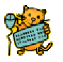
GOALS:
- To get familiar with English alphabet (visual representation and the sound of the letters)
- To get familiar with laptop keyboard, doing the association between the letter on the screen and on the keyboard.

CONTEXTUALIZATION: Say loud or sing a song for the English alphabet.

HOW TO PLAY: Type the falling letters before they reach the ground.

Click to enable the sound and uppercase
CLICK:

