
LESSON PLAN
NUMERATION – subtraction
Gcompris


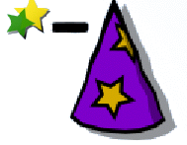
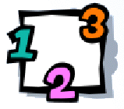

CLICK:

GOALS:
- To develop the subtraction skills.

CONTEXTUALIZATION: Use real items (ex: 4 pencil, 2 chalk) to simulate the subtraction. Put some items inside a bag and take some out. Ask to kids to say how many staid inside.

HOW TO PLAY: Click on the hat to open it. Some stars will enter. Count how many starts can you see moving to under the hat. Click on the stars after = to answer. Check the answer .

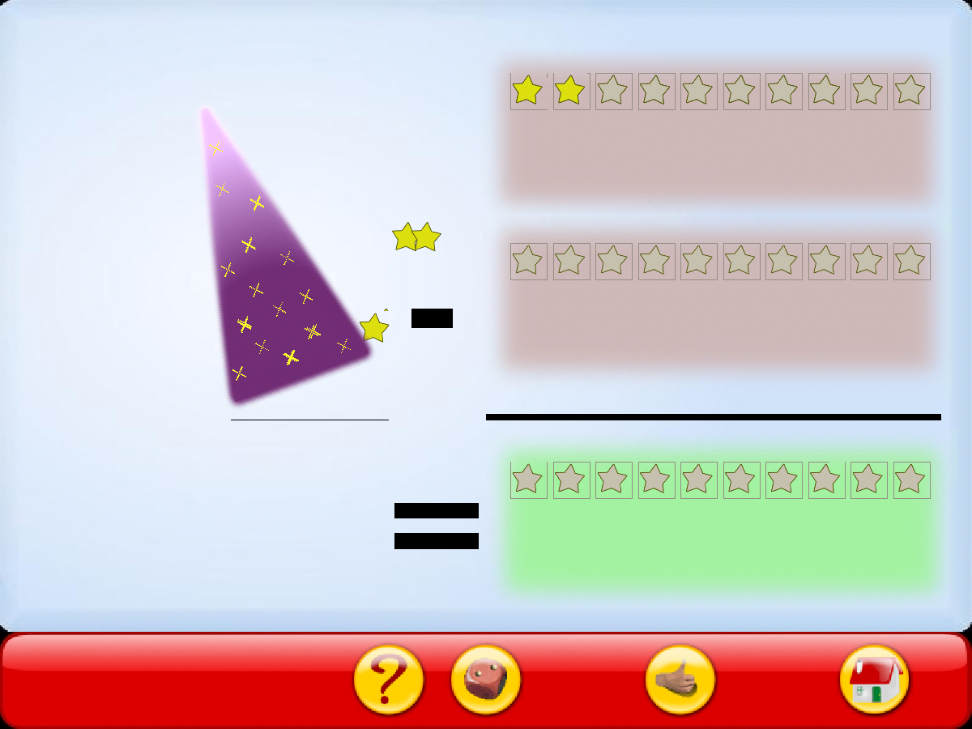
Click on stars to give the answer

