
LESSON PLAN
LOGIC – SUDOKU


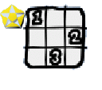
CLICK:

GOALS:
- To develop logical skills.

HOW TO PLAY: For the level 1, drag and drop the shapes on the table. But you need different symbols in each line and in each column. You can’t repeat the shapes in the same line and in the same column. Complete all table.
After the level 4, you have number instead of shapes. The logic is the same.
