Help your students improve their understanding of angles as they create shapes and designs using Turtle Art.
Turtle Art: Geometry

How:
Turtle Art uses geometry to create shapes, patterns and designs. To give your students an introduction to angles, challenge them to create a square, triangle and circle in Turtle Art.
2. Once you have your block in the middle, click on it. You will see that you Turtle will either make a line, if you chose ‘forward’ or ‘back’ or will turn at an angle if you chose ‘right’ or ‘left’
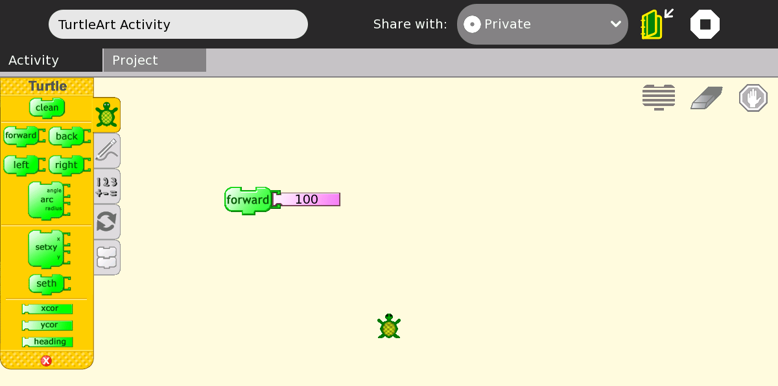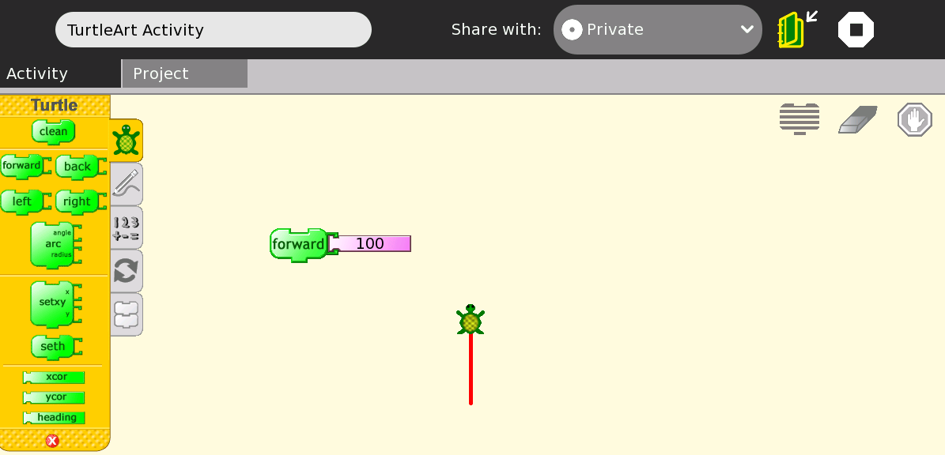
1. Open Turtle Art. Click on the blocks on the left of the screen and drag them to the middle of the screen:
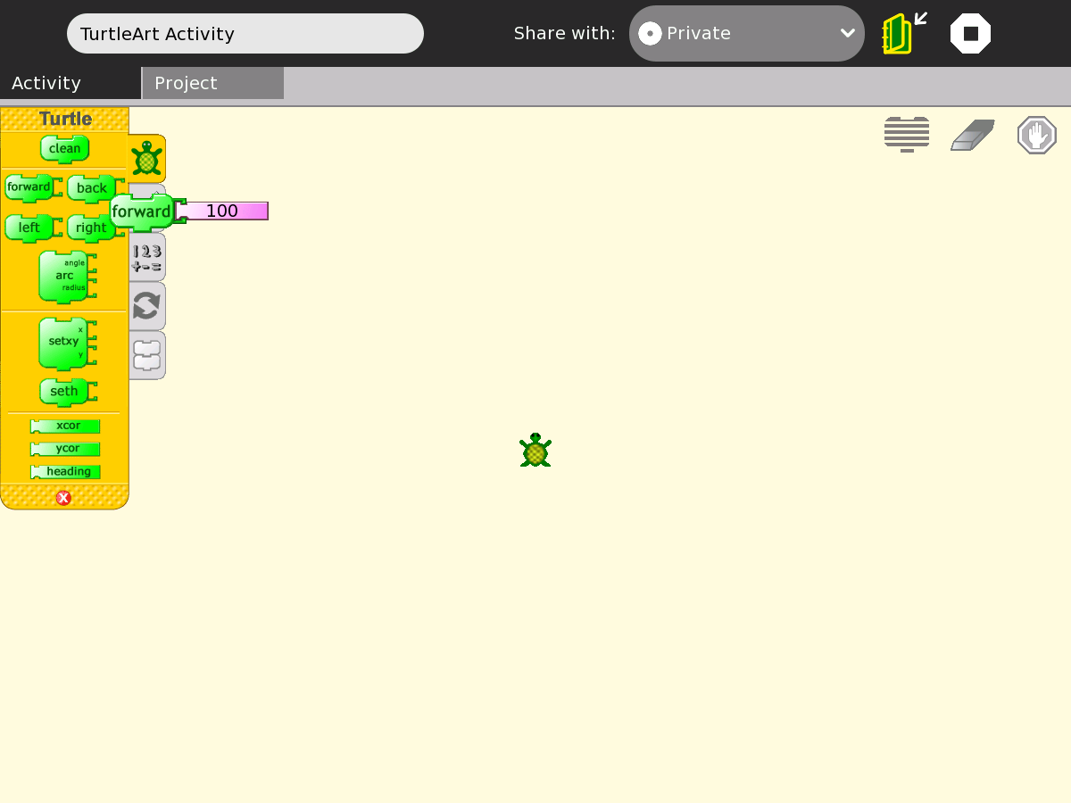
Just follow these steps:

When you click on a block, keep holding down until it is in the middle of the screen

3. Add another block to the first block you brought out. You can do that by attaching it either on top or bottom. Remember: the Turtle will do what you told it to do in order from the top. My Turtle went ‘forward 100’ then turned ‘right 90’:
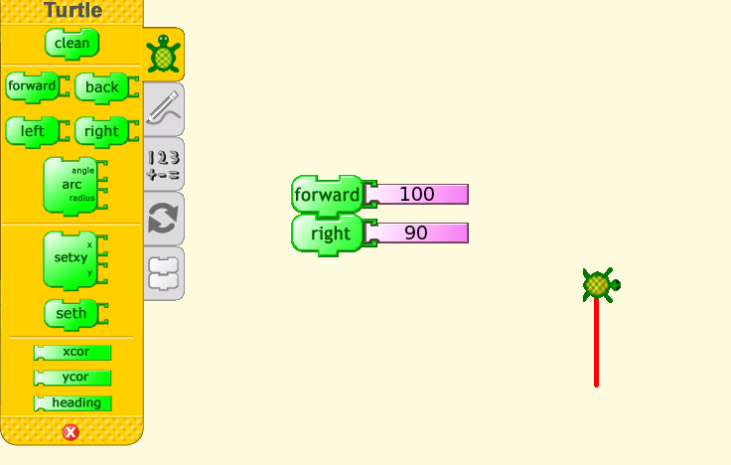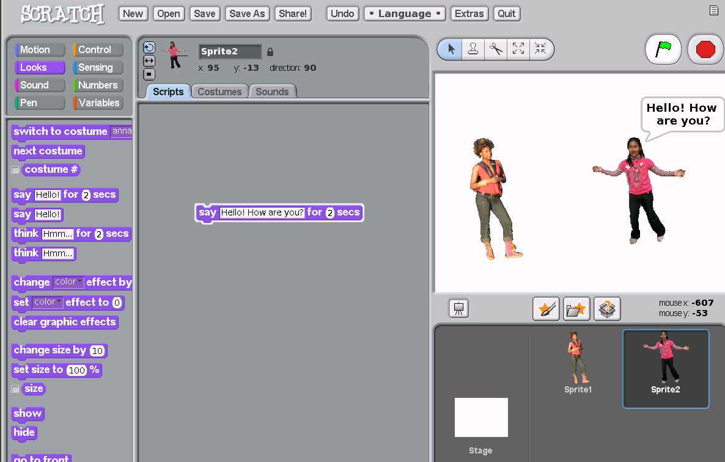

4. Let’s make a square. See how I connected all my blocks? Now all I have to do is click once on any block and my Turtle makes a square.
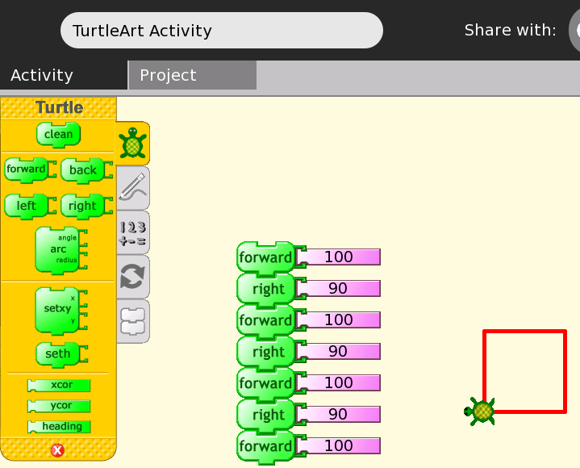

You can also click on the number, press ‘erase’ and change it

5. Now I want to make my circle. Just click on the Turtle, keep holding down and drag it to another place on the screen. If you click on the Turtle’s head you can also change the way it is facing.

6. I moved my Turtle so that I could make three separate shapes. Remember: you can click on a block before connected it to the other blocks if you are not sure it will work, see:
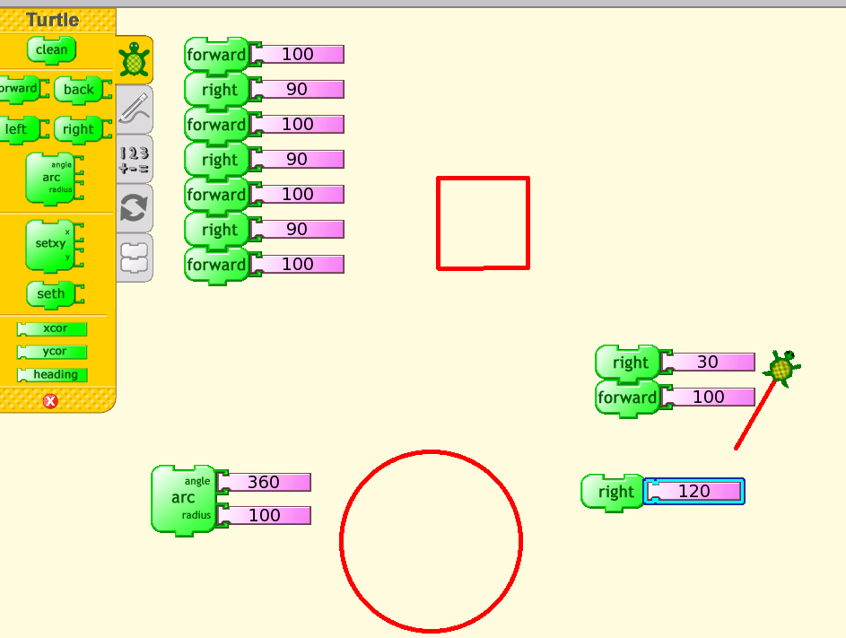
To erase, click here: 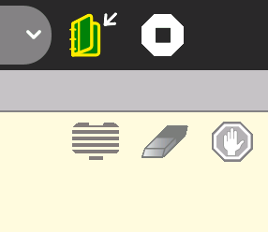
kj

7. Now I made all 3 shapes. Now ask your students to do the same