
LESSON PLAN
NUMERATION
Gcompris

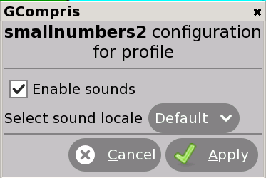
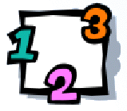


CLICK here to enable the sound
CLICK:

GOALS:
- To develop the counting skills and the visual representation of the number.
- To get familiar with addition.

CONTEXTUALIZATION: Count the dots of the dice. You can use a real dice or draw it on the blackboard.

HOW TO PLAY: In the keyboard, type the number of dots you see on the falling dice.
