
LESSON PLAN
NUMERATION - counting
Gcompris

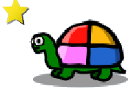
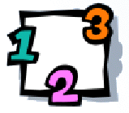

CLICK:

GOALS:
- To develop the counting skills and the visual representation of the number.
- To do classification of objects (separation in groups).

CONTEXTUALIZATION: Use real items (ex: 4 pencil, 2 chalk, 1 eraser) and ask them to separate in groups and after, write the number of each object.

HOW TO PLAY: First, organize the items in groups, dragging and dropping them on the Turtle. It will facility to count them.
Select the item you want to answer in the bottom area. Enter the answer with the keyboard and press OK button .

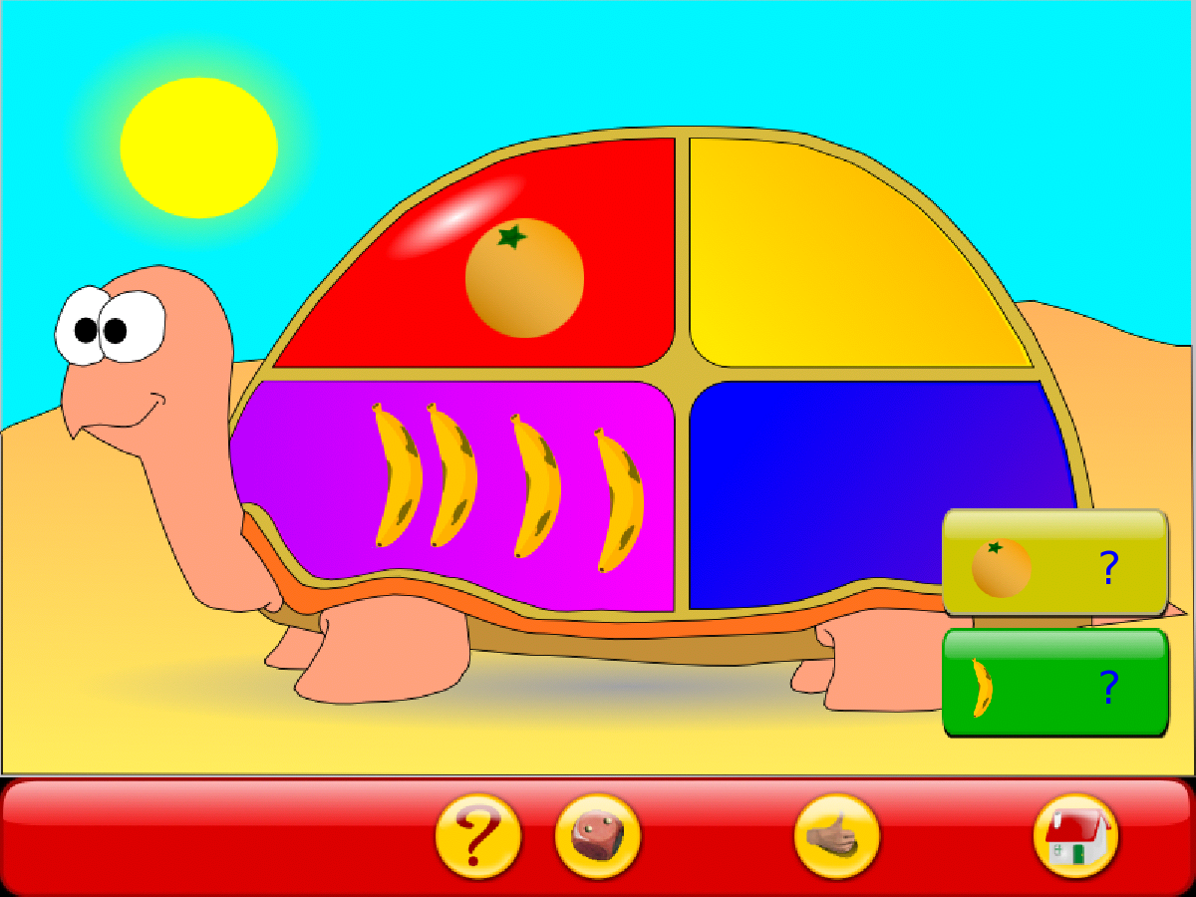
Click on ? and type the answer

